1. About left and right arrow in the About screen

When the user clicks on the left / right arrow in the about screen, it rotates the different images (clockwise / counter clockwise) which explain about the music. I have provided the series of screenshot which get displayed when we click on left / right arrow buttons

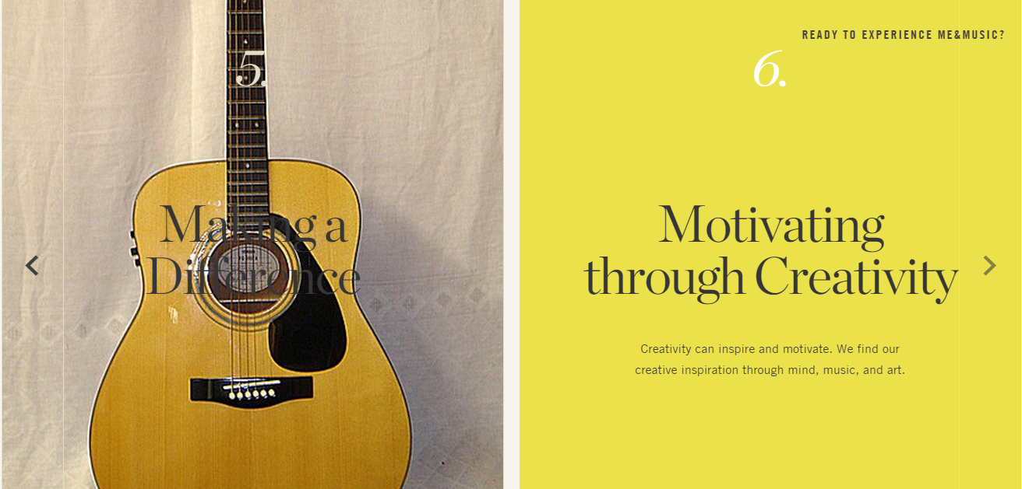

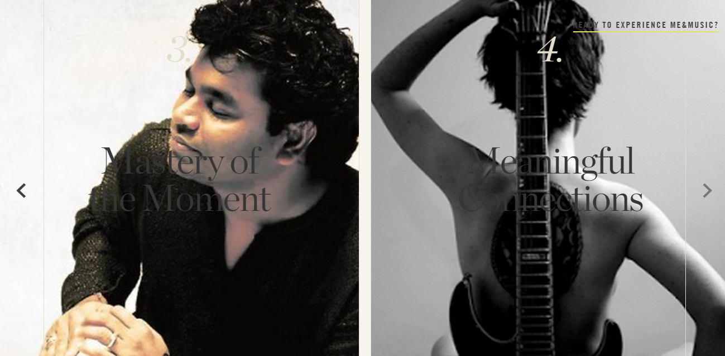

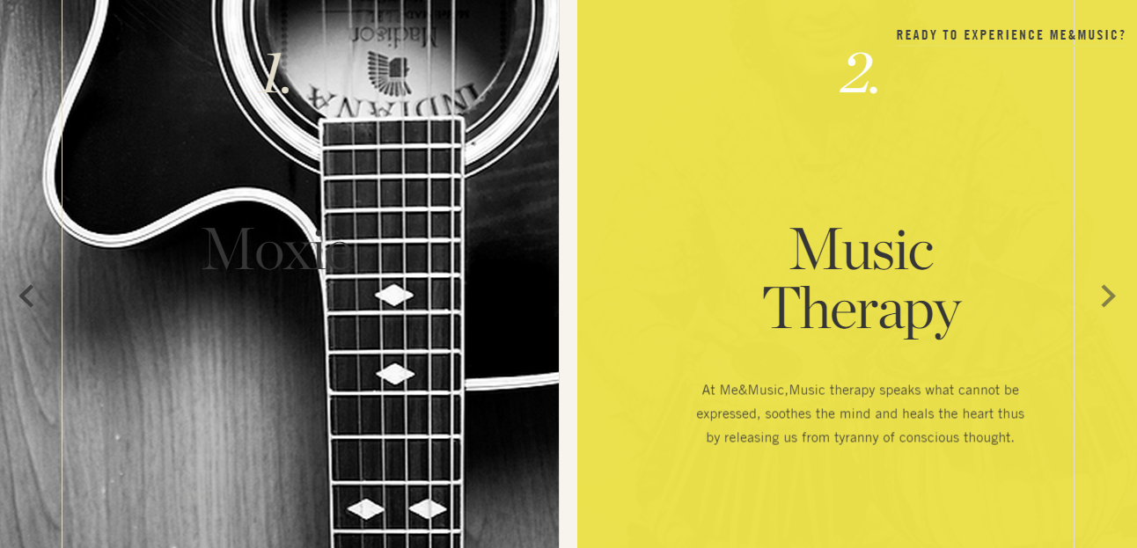

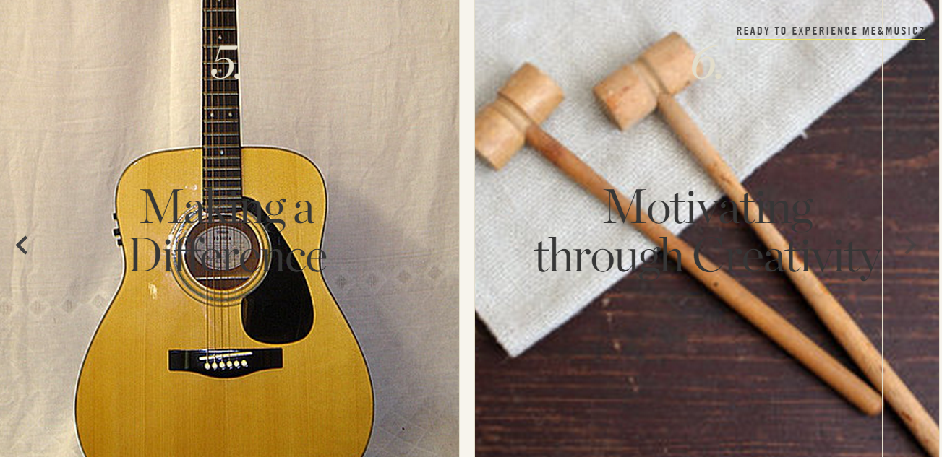

1. Class page screen shot

